**LISTED**

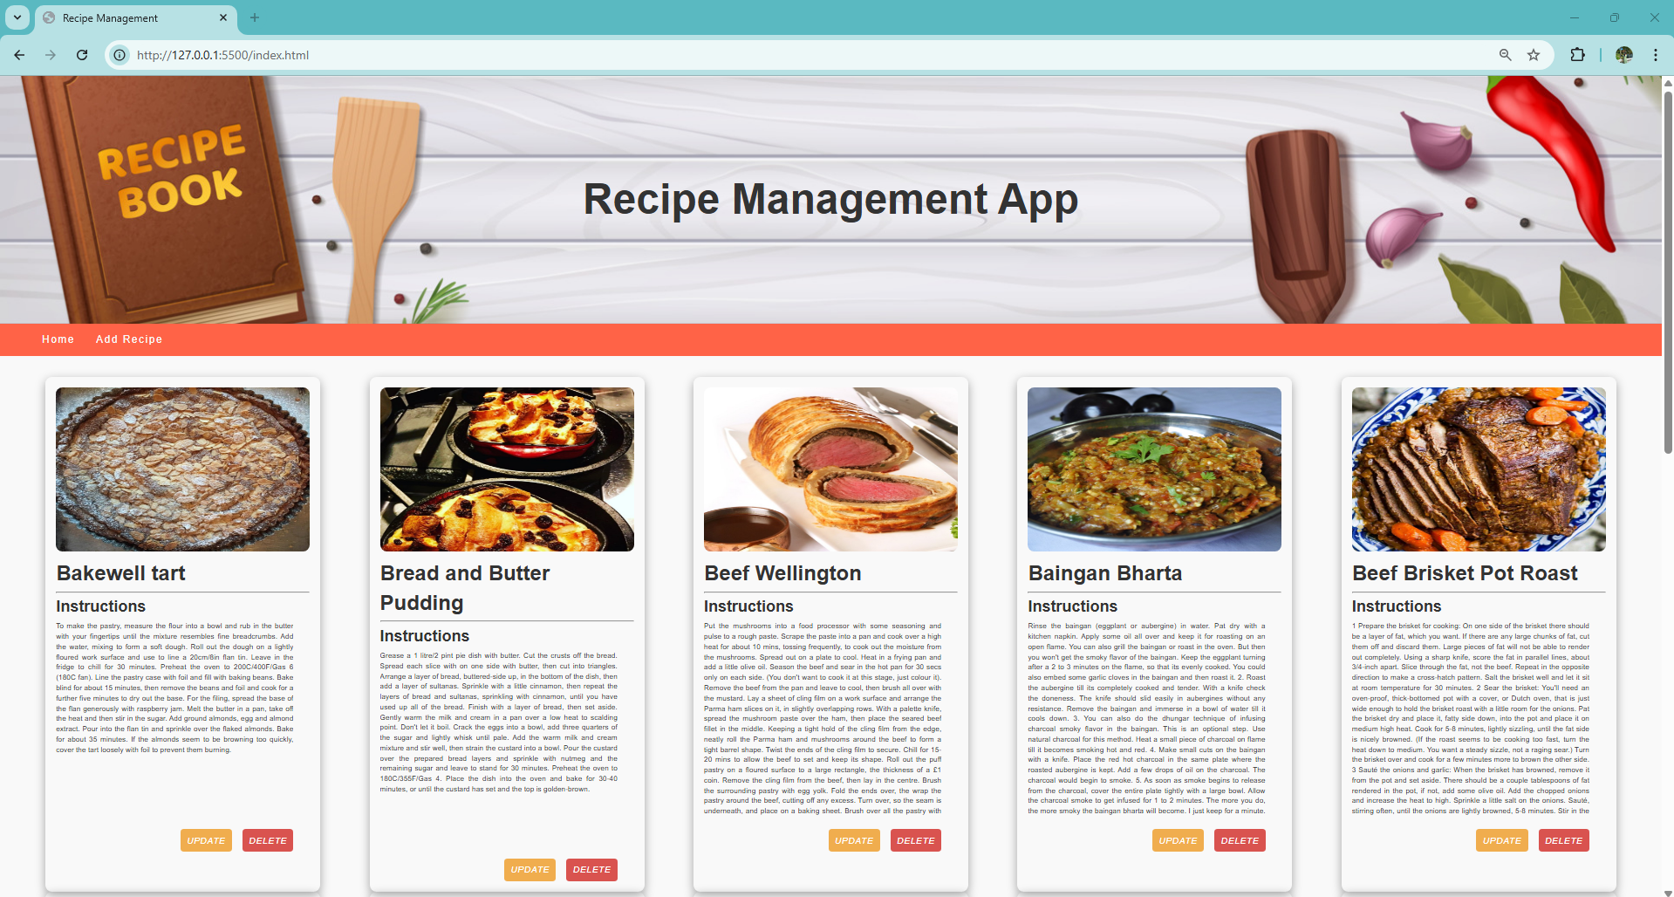

**ADDED**

